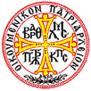

Past
ECCLESIASTICAL HISTORY AND FORMER MEMBERS PAST AND PRESENT
ARCHDIOCESE OF TARPON SPRINGS AND WEST PALM BEACH OF
THE HOLY UKRAINIAN AUTOCEPHALIC ORTHODOX CHURCH IN EXILE AND THE HOLY GREEK PAN ORTHODOX AUTOCEPHALOUS ARCHDIOCESE
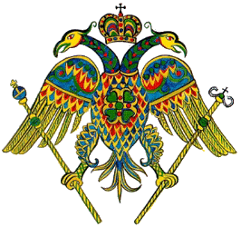

His Eminence, Archbishop HARALAMPIJ
HARALAMPIJ, the Most Reverend and God-Chosen Archbishop of Tarpon Springs and West Palm Beach and President of the Consistory of the Holy Ukrainian Autocephalic Orthodox Church in Exile and Holy Greek Pan Orthodox Autocephalous Archdiocese, our Father and Chief Shepherd, many years to him!
PARISHES/MONASTERIES
St. Michael Evangelical Orthodox Church, West Palm Beach, FL
Holy Theotokos Monastery, West Palm Beach, FL
Holy Theotokos Shrine, Jensen Beach, FL
Saint Michael Academy Orthodox College
Greek Orthodox Church, New Port Richey, Florida (Inactive)

CLERGY AND/OR MONASTICS
Bishop George Sygrimis (Deceased)
Fr. Stefanos Vlahopoulos (Retired)
Fr. Matthew Adair (Retired)
Deacon Leo Czarneki (Deceased)
Bishop Paul Lambert (Deceased)
Deacon Carlton Woods (Deceased)
Fr. John H. Vesey (Deceased)
Fr. David Attard
Deaconess Joy Ebersole
Deaconess Anna Vesey
Deaconess Lois Bouchlas
Deaconess Maria

